**APPLICATION CONTAINERIZATION**

**LAB EXPERIMENT 7**

**SUBMITTED BY:**

NITISH KUMAR SINGLA

500071913

R171218126

**SUBMITTED TO:**

HITESH KUMAR SHARMA SIR

**Docker Swarm**

Swarm Mode Initialisation

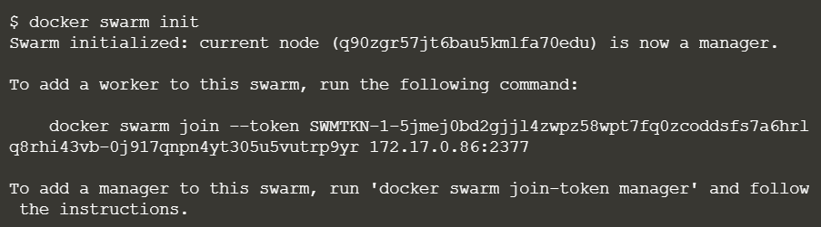

On the second host, join the cluster by requesting access via the manager. The token is provided as an additional parameter.



View all nodes in the cluster

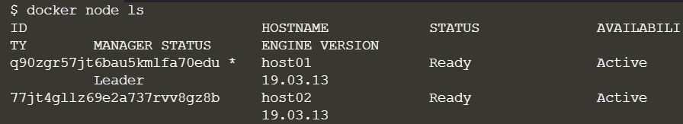

The following command will create a new overlay network called skynet.



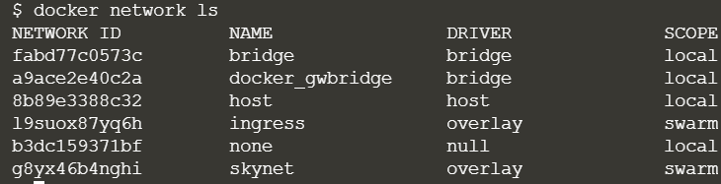

You can view the services running on the cluster using the CLI command



Finally, we load balance these two containers together on port 80

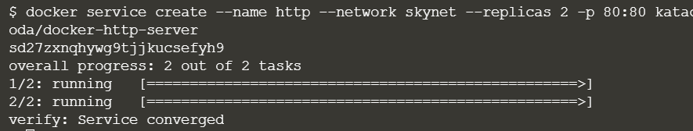

You can view the services running on the cluster using the CLI command

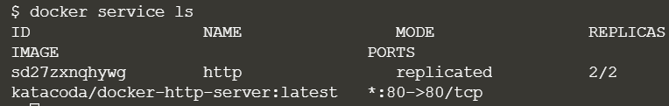

List containers on the first host

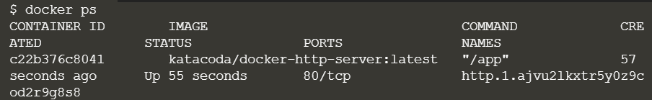

List containers on the second host

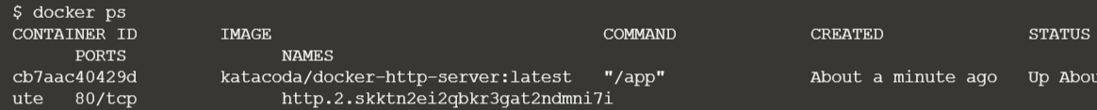

If we issue an HTTP request to the public port, it will be processed by the two containers



You can view the list of all the tasks associated with a service across the cluster. In this case, each task is a container

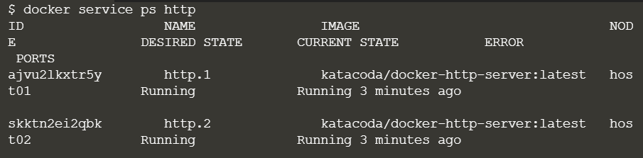

You can view the details and configuration of a service via

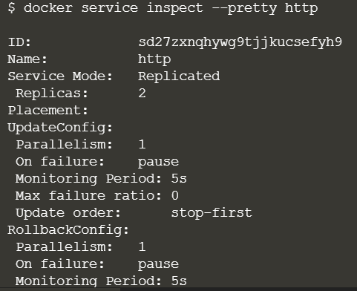

On each node, you can ask what tasks it is currently running. Self refers to the manager node Leader

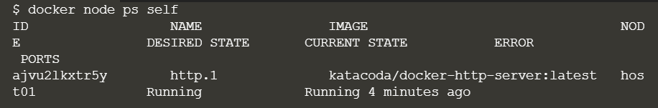

Using the ID of a node you can query individual hosts

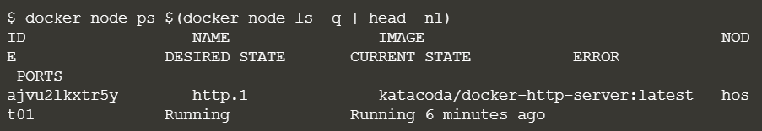

At present, we have two load-balanced containers running, which are processing our requests



The command below will scale our http service to be running across five containers.

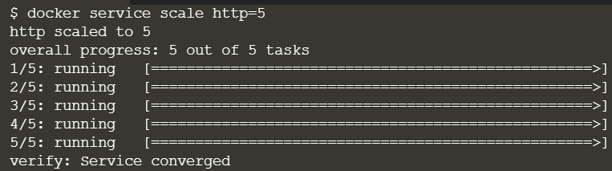

On each host, you will see additional nodes being started

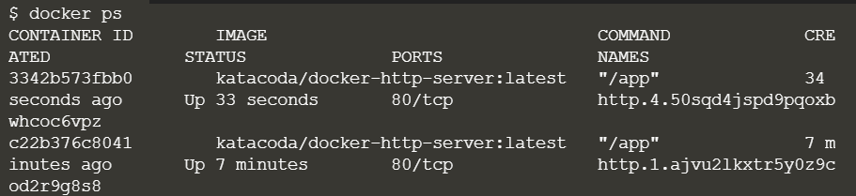

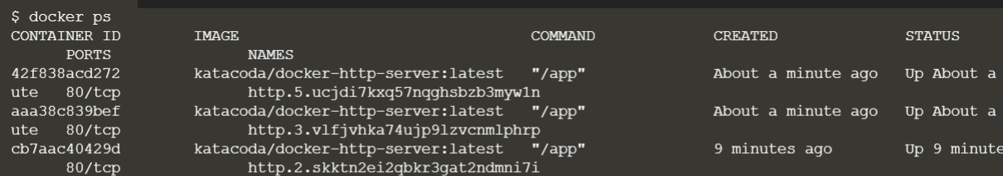

The load balancer will automatically be updated. Requests will now be processed across the new containers. Try issuing more commands via

